**EXP 1: IMPLEMENTATION OF LEXICAL ANALYSER**

**AIM :**

* Implementation of Lexical Analyser using python

**PROCEDURE:**

* Creating a file with simple program.
* Assigning the keyword, operators and punctuations.
* Making a loop to move for every line and each character and using a if condition to divided the tokens from the file.
* Printing tokens to their induvial keywords
* At last it shows no of tokens.

**SOURCE CODE:**

line = (input("Enter : "))  
keywords = ["void", "main", "int", "float", "bool", "if", "for", "else", "while", "char", "return"]  
operators = ["=", "==", "+", "-", "*", "/", "++", "--", "+=", "-=", "!=", "||", "&&"]  
punctuations= [";", "(", ")", "{", "}", "[", "]"]  
  
def is_int(x):  
 try:  
 int(x)  
 return True  
 except:  
 return False  
  
for i in line.strip().split(" "):  
 if i in keywords:  
 print (i, " is a keyword")  
  
 elif i in operators:  
 print (i, " is an operator")  
  
 elif i in punctuations:  
 print (i, " is a puctuation")  
  
 elif is_int(i):  
 print (i, " is a number")  
  
 else:  
 print (i, " is an identifier")

**INPUT:**

**Int** b = 5  
for i in range ( 0 , b ) :  
print ( i )

**OUTPUT:**

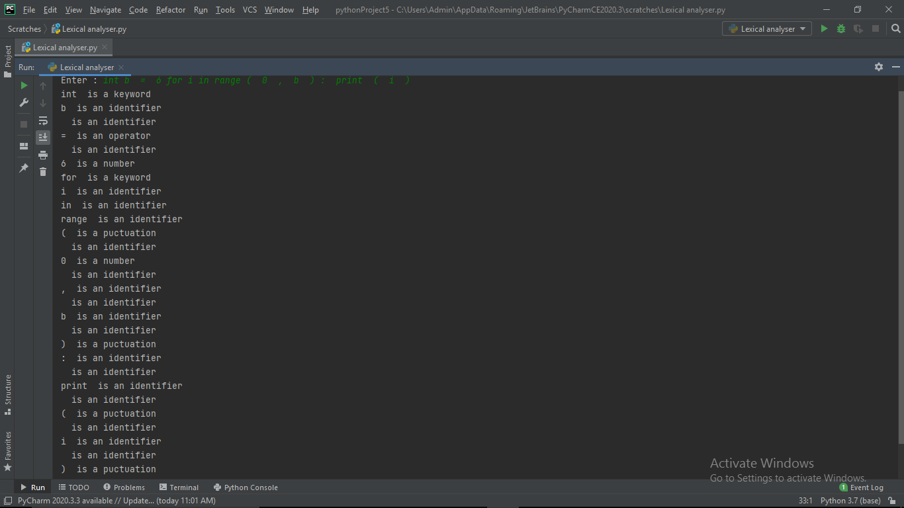

**RESULT:**

* Implementation of Lexical Analyser using python is done.